**9. Delete Pod**

**Get YAML Output of Pod & Service**

**# Get pod definition YAML output**

--- **kubectl get pod my-first-pod -o yaml**

**# Get service definition YAML output**

--- **kubectl get service my-first-service -o yaml**

**Clean-Up**

**# Get all Objects in default namespace**

--- **kubectl get all**

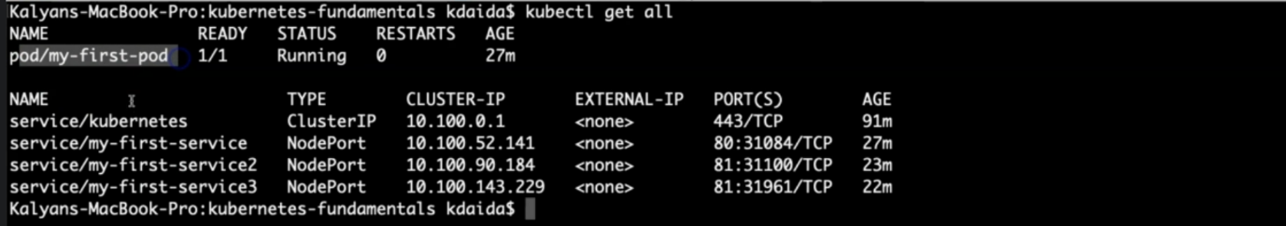

**# Delete Services**

--- **kubectl delete svc my-first-service**

--- **kubectl delete svc my-first-service2**

--- **kubectl delete svc my-first-service3**

**# Delete Pod**

--- **kubectl delete pod my-first-pod**

**# Get all Objects in default namespace**

--- **kubectl get all**